OFFICE  USE | MEMBERSHIP NO.
OFFICE  USE | START DATE
OFFICE  USE | END DATE

Charity No 264364.
28/02/2021
MEADOWSIDE FRIENDS MEMBERSHIP FORM
TITLE |  | FORENAME |  |  |  |  |  |  |  |  |  |  |  | SURNAME
ADDRESS
POST CODE |  |  |  |  | TELEPHONE |  |  |  |  |  |  |  |  |  | EMAIL
MEMBERSHIP TYPE  [PLEASE TICK] |  |  | ANNUAL £18.00 |  |  |  |  |  |  |  | THREE YEAR £50.00 |  |  |  |  |  |  | LIFETIME £150.00
PAYMENT METHOD [PLEASE TICK] |  |  |  |  |  |  | CHEQUE |  |  |  |  |  | BACS |  |  |  |  |  | ONLINE
CHEQUE or |  | BANK PAYMENT |  |  |  |  | TO :- “THE MEADOWSIDE CHARITY NEWTON ABBOT & DISTRICT”
ACCOUNT |  | 35635468 |  |  |  | SORT |  | 30:84:67 |  |  |  | REFERENCE |  |  |  | FRIEND / YOUR SURNAME
ONLINE |  | VIRGIN MONEY |  |  |  |  | CLICK ON THE LINK |  |  |  |  |  |  |  |  | https://bit.ly/2Zn6nm4
RETURN YOUR COMPLETED  FORM BY POST TO: |  |  |  | Friends @Meadowside Charity,41 Highweek Road, Newton Abbot,TQ12 1TR
RETURN YOUR COMPLETED FORM BY EMAIL TO: |  |  |  |  |  |  |  |  |  | Friends@meadowsidecharity.co.uk
BOOST YOUR MEMBERSHIP SUBSCRIPTION BY 25P FOR EVERY £1 BY TICKING THIS BOX

I agree to gift aid this membership subscription of £ or have made in the past 4 years and any donations I make in the future.
Gift aid is reclaimed by the charity from the tax you pay for the current tax year.
Your address is needed to identify you as a current UK taxpayer

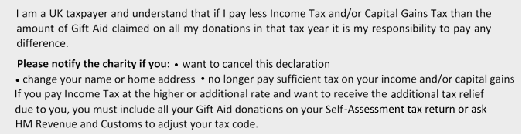
By completing this form, you agree that the Friends of Rotary may store your contact details, they will only be used to contact you in relation to the Meadowside Charity. They will NOT be distributed or sold to a third party.
IF YOU ARE ABLE TO HELP WITH SERVICES OR RELEVANT EXPERTISE YOU WOULD REALLY BE A FRIEND INDEED!

